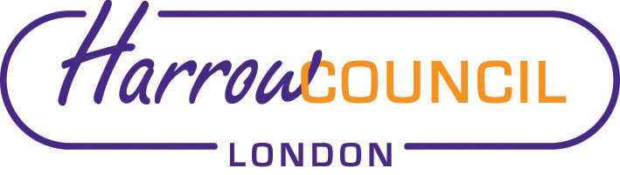
Harrow SACRE Meeting

Tuesday 29 June 2021 at 7.30 p.m.
To be held via video conferencing

Enquiries & apologies to:
Vivian Wright, Clerk to SACRE
vmwright@waitrose.com

Adviser to SACRE: Lesley Prior

Agenda
- Welcome:

- Apologies for absence:

- Election of Chair and Vice-Chair.

- Minutes of the last meeting on 9 March 2021 (attached): to agree the minutes as a true record.

- Matters arising from the minutes

- RE and Ofsted
- Ofsted paper on RE:
- National context in relation to RE;
- Review of research into factors that affect the quality of education in RE;
- Curriculum progression in RE, pedagogy, assessment and impact of school leaders’ decisions.
- Link to paper: https://www.gov.uk/government/publications/research-review-series-religious-education/research-review-series-religious-education

- Reflections from AGM – David and Camilla (Richard Kueh, Chief HMI at Ofsted for RE, was a keynote speaker)
Video from Richard Kueh: https://twitter.com/ofstednews/status/1390252584947044354?s=21

- Other local and National updates

- Collective Worship Policy

- Determinations
- Vaughan Determination – deferred.

- Priorities for the year ahead

- News from Faith Groups relating to schools

- Any Other Business

- Future Dates
- Tuesday 28 September
- Thursday 2 December
- Tuesday 8 March 2022

